Student Name: SAKSHAM SAXENA

Registration Number: 21BCE11103

VIT Campus: Bhopal

Assignment-3

September 9th, 2023

LOGIN ACCOUNT TO SHOPPING SITES

**MAIN CODE—**

package com.example.newsigninpage  
  
import android.R  
import android.content.ActivityNotFoundException  
import android.content.Intent  
import android.net.Uri  
import android.os.Bundle  
import android.widget.Toast  
import androidx.activity.ComponentActivity  
import androidx.activity.compose.setContent  
import androidx.compose.foundation.Image  
import androidx.compose.foundation.layout.Arrangement  
import androidx.compose.foundation.layout.Column  
import androidx.compose.foundation.layout.Spacer  
import androidx.compose.foundation.layout.fillMaxSize  
import androidx.compose.foundation.layout.fillMaxWidth  
import androidx.compose.foundation.layout.height  
import androidx.compose.foundation.layout.padding  
import androidx.compose.foundation.layout.size  
import androidx.compose.foundation.text.KeyboardActions  
import androidx.compose.foundation.text.KeyboardOptions  
import androidx.compose.material3.Button  
import androidx.compose.material3.ExperimentalMaterial3Api  
import androidx.compose.material3.*LocalContentColor*import androidx.compose.material3.MaterialTheme  
import androidx.compose.material3.Surface  
import androidx.compose.material3.Text  
import androidx.compose.material3.TextField  
import androidx.compose.runtime.Composable  
import androidx.compose.runtime.getValue  
import androidx.compose.runtime.mutableStateOf  
import androidx.compose.runtime.remember  
import androidx.compose.runtime.setValue  
import androidx.compose.ui.Alignment  
import androidx.compose.ui.Modifier  
import androidx.compose.ui.graphics.Color  
import androidx.compose.ui.platform.*LocalContext*import androidx.compose.ui.res.painterResource  
import androidx.compose.ui.text.font.FontWeight  
import androidx.compose.ui.text.input.ImeAction  
import androidx.compose.ui.text.input.KeyboardType  
import androidx.compose.ui.tooling.preview.Preview  
import androidx.compose.ui.unit.dp  
import com.example.newsigninpage.ui.theme.NewSignInpageTheme

class MainActivity : ComponentActivity() {  
 override fun onCreate(savedInstanceState: Bundle?) {  
 super.onCreate(savedInstanceState)  
 *setContent* **{** Surface(  
 modifier = Modifier.*fillMaxSize*(),  
 color = Color.DarkGray  
 ) **{** NewSignInpageTheme()  
 **}  
 }** }  
  
 @OptIn(ExperimentalMaterial3Api::class)  
 @Composable  
 fun NewSignInpageTheme() {  
 var username by remember **{** *mutableStateOf*("") **}** var password by remember **{** *mutableStateOf*("") **}** val context = *LocalContext*.current  
  
 Column(  
 modifier = Modifier.*fillMaxSize*(),  
 verticalArrangement = Arrangement.Center,  
 horizontalAlignment = Alignment.CenterHorizontally  
 ) **{** Text(  
 text = "LOGIN ACCOUNT",  
 style = MaterialTheme.typography.headlineMedium.copy(*Color*(0xFF87B340)),  
 fontWeight = FontWeight.Bold  
  
 )  
  
 Image(  
 painter = painterResource(id = R.drawable.*arrow_down_float*),  
 contentDescription = "Login page",  
 modifier = Modifier  
 .*size*(150.*dp*)  
 .*padding*(16.*dp*)  
 )  
  
 TextField(  
 value = username,  
 onValueChange = **{** username = **it }**,  
 modifier = Modifier.*fillMaxWidth*(),  
 label = **{** Text(text = "Enter your Username") **}** )  
  
 Spacer(modifier = Modifier.*height*(16.*dp*))

TextField(  
 value = password,  
 onValueChange = **{** password = **it }**,  
 modifier = Modifier.*fillMaxWidth*(),  
 label = **{** Text(text = "Enter Password") **}**,  
 keyboardOptions = KeyboardOptions(  
 keyboardType = KeyboardType.Password,  
 imeAction = ImeAction.Done  
 ),  
  
 keyboardActions = KeyboardActions(  
 onDone = **{  
 }** )  
 )  
  
 Spacer(modifier = Modifier.*height*(16.*dp*))  
  
 Button(  
 modifier = Modifier.*padding*(16.*dp*),  
 onClick = **{** val intent = Intent(Intent.*ACTION_VIEW*)  
 intent.*data* = Uri.parse("https://www.flipkart.com")  
  
 if (intent.resolveActivity(context.*packageManager*) != null) {  
 context.startActivity(intent)  
 }  
 else {  
 Toast.makeText(context, "No web browser available",  
 Toast.*LENGTH_LONG*).show()  
 }  
 **}**,  
 ) **{** Text(text = "Sign-In to Flipkart")  
 **}** Button(  
 modifier = Modifier.*padding*(16.*dp*),  
 onClick = **{** val intent = Intent(Intent.*ACTION_VIEW*)  
 intent.*data* = Uri.parse("https://www.amazon.com")  
  
 if (intent.resolveActivity(context.*packageManager*) != null) {  
 context.startActivity(intent)  
 }  
 else {  
 Toast.makeText(context, "No web browser available",  
 Toast.*LENGTH_LONG*).show()  
 }  
 **}**,  
 ) **{** Text(text = "Sign-In to Amazon")  
 **}**

Button(  
 modifier = Modifier.*padding*(16.*dp*),  
 onClick = **{** val intent = Intent(Intent.*ACTION_VIEW*)  
 intent.*data* = Uri.parse("https://www.myntra.com")  
  
 if (intent.resolveActivity(context.*packageManager*) != null) {  
 context.startActivity(intent)  
 }  
 else {  
 Toast.makeText(context, "No web browser available",  
 Toast.*LENGTH_LONG*).show()  
 }  
 **}**,  
 ) **{** Text(text = "Sign-In to Myntra")  
 **}  
 }** }  
}

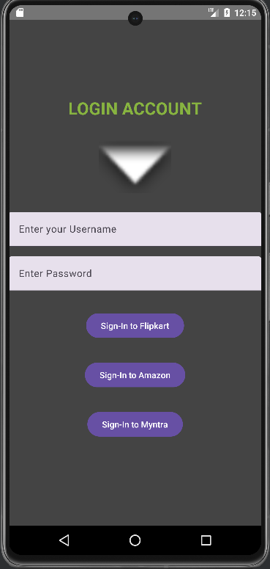

**OUTPUT—**